Finding the Titanic
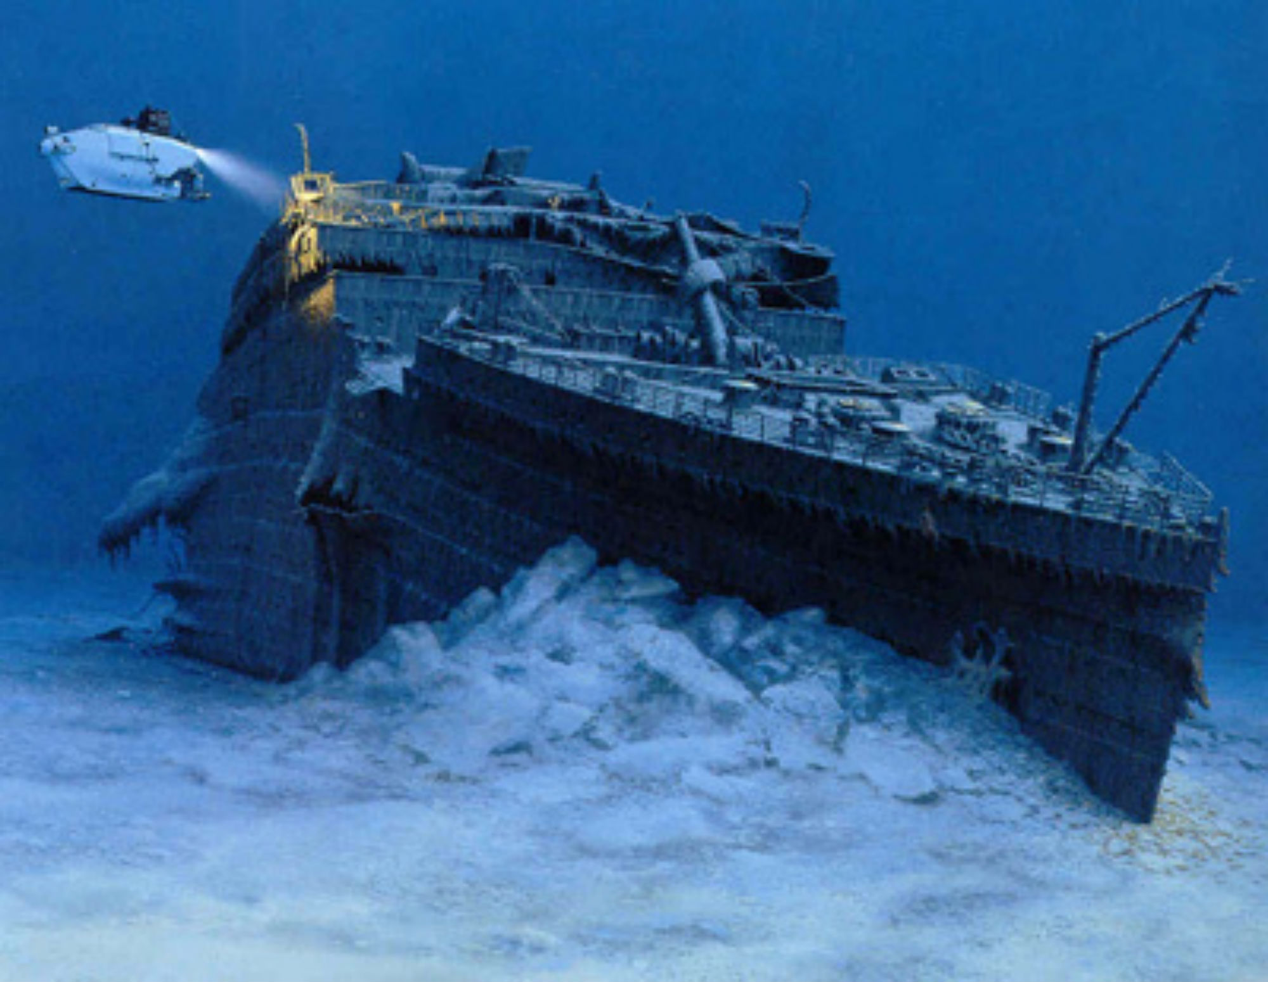
By: Robert D. Ballard

Chapter 1: August 25, 1985

The Titanic was a huge ship. On its first trip the Titanic hit an iceberg and sank. There were 2,000 people on it and many of them died.
I have wanted to find the Titanic since I was a little boy. It is on the bottom of the Atlantic Ocean and too far for a diver to go.
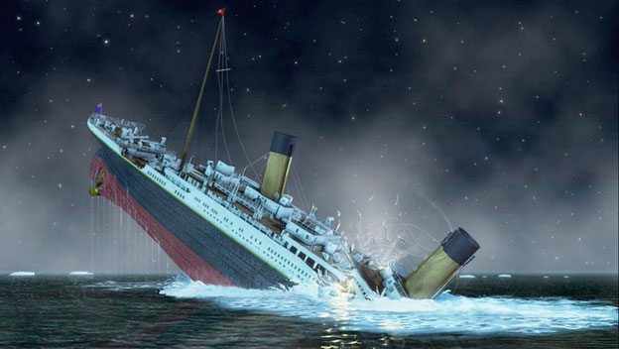
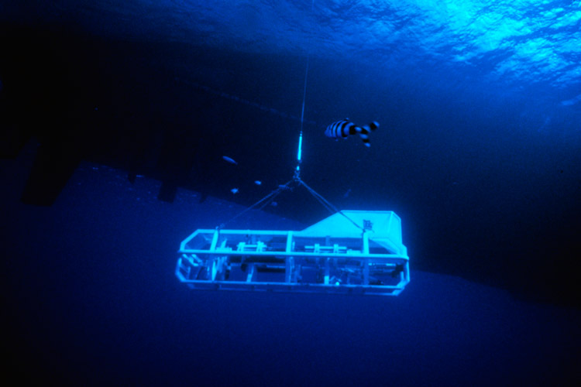
Today I am going to try and find the Titanic. I helped build an underwater sled to help search for it. I named the sled Argo. It can take pictures as it moves along the ocean floor.
We started searching in the area where rescue ships found the Titanic’s lifeboats. The cameras didn’t find anything but mud.

Chapter 2: April 10, 1912
A long time ago a little girl named Ruth was in England getting ready to get on a huge ship called the Titanic. Ruth and her family were going to sail from England to America. It would be a long trip. Ruth thought the ship was huge and beautiful. Inside it looked like a fancy hotel.

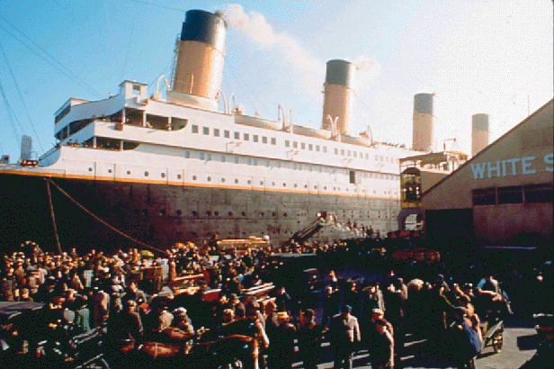

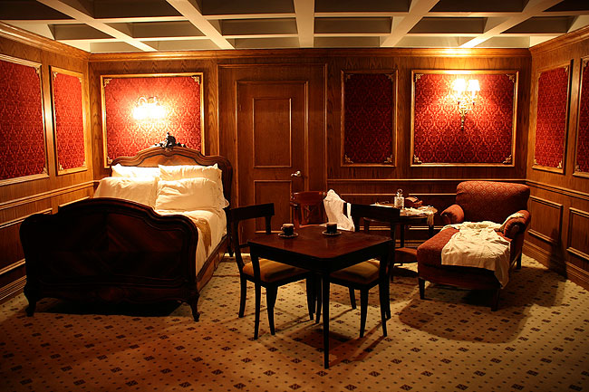

After the ship set sail Ruth went exploring. She found the rooms where people with a lot of money were staying. They were so big and beautiful. Near the fancy rooms there was even a swimming pool!

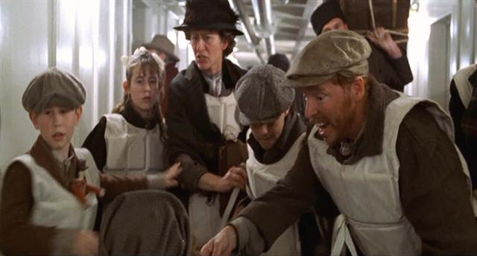

In the lower part of the ship it was very crowded. There were a lot of people who wanted to go to America and have a better life.

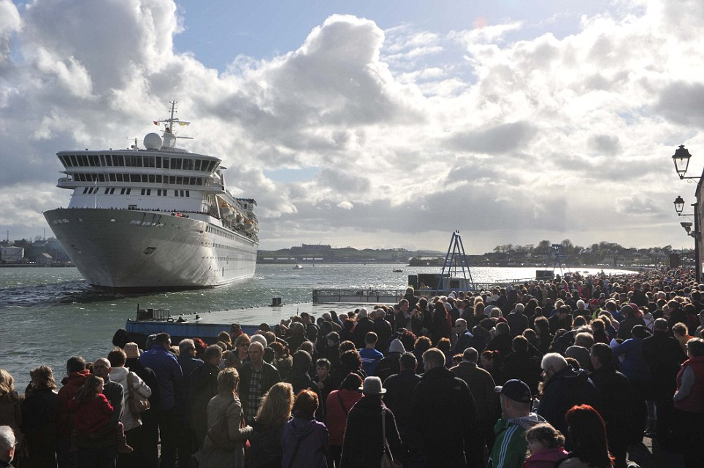

As the Titanic pulled away from the dock hundreds of people cheered. They were very excited to see this big boat set off for America.
For the first few days the weather was very nice. The ocean was calm. Ruth and her family ate in the dining room at long tables with other families.
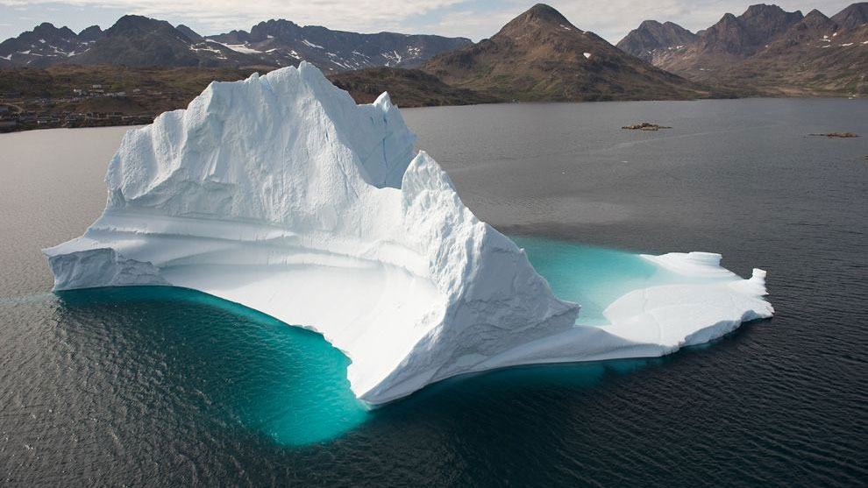

On Sunday afternoon it got very cold. People started talking about how there could be ice in the ocean. They even talked about big pieces of ice that stick out of the ocean called icebergs.

Chapter 3: April 15, 1912
12:30 a.m.
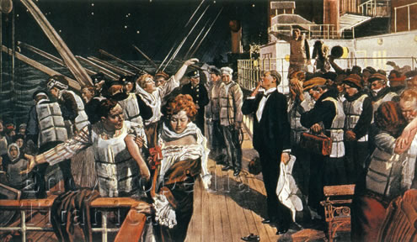
Ruth’s mom woke her up in the middle of the night. She told Ruth and her brother and sister to put on coats. She sounded very scared. She told Ruth that the ship had hit an iceberg. All of the people on the ship left their rooms and went to the deck of the ship. No one knew how much the iceberg damaged the boat or if water was getting into the boat. Some people put on their life vests, but many of them had forgotten their vests in their rooms.

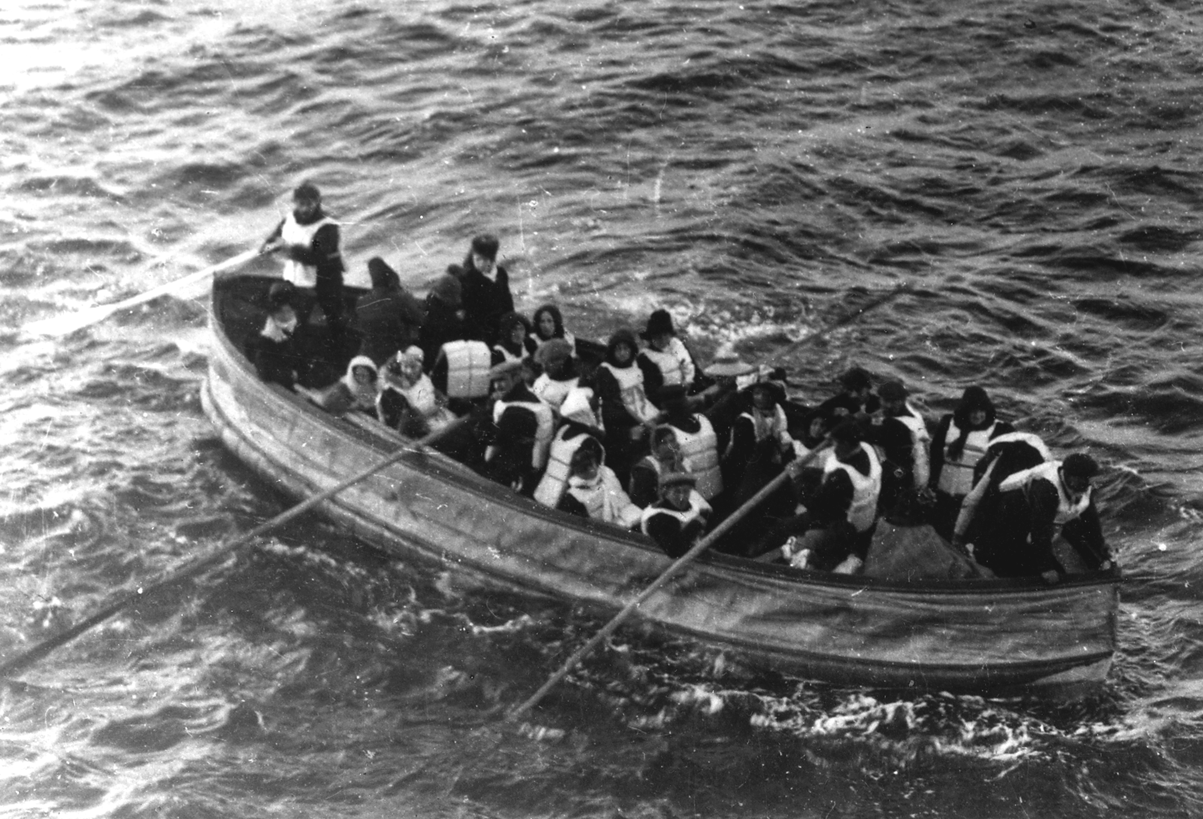

The crew helped people into small boats called lifeboats. The women and children got to get in the boats first. Ruth’s mom, brother and sister got in a boat but Ruth couldn’t fit. She got into another boat with people she didn’t know.

From the little boat Ruth looked back at the Titanic. There were still so many people on it. There were not enough boats for all of them.

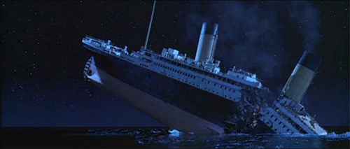

As they rowed away Ruth watched as the Titanic started to sink into the ocean. People tried to run toward the back of the ship. Then there was a loud noise like thunder. The Titanic broke apart. People jumped into the ocean.

Chapter 4: April 10, 1912
3:00 a.m.

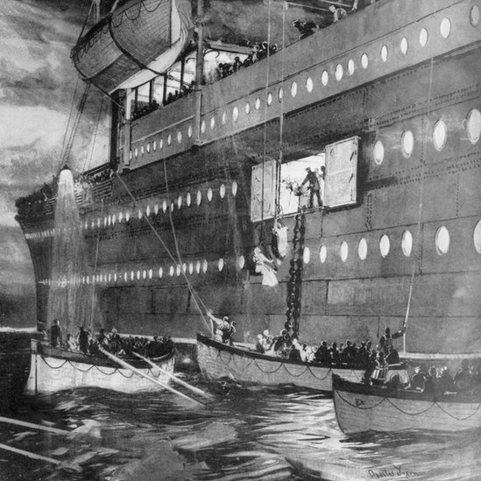
On the little lifeboat Ruth was scared. She heard someone say the Titanic would be all covered by ocean water soon. Far away she saw lights. The passengers kept rowing their lifeboat toward the light. It was a big ship. They put down a ladder and people from the lifeboats climbed up into the big ship.
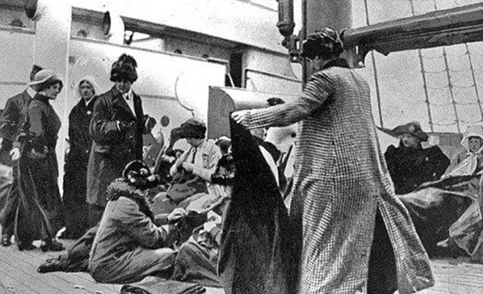

The rescue ship was called the Carpathia. On the ship a woman tapped Ruth on the shoulder and told her that her mother was in the dining room looking for her. Many people were finding their families, but many people were crying as they looked for their loved ones who had drowned in the ocean.

Chapter 5: August 31, 1985
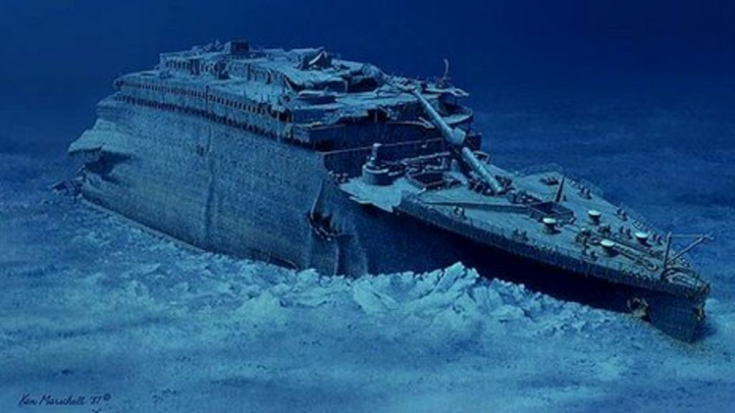
It has been almost 75 years since the Titanic sank and now my crew and I are searching for it. We have looked for days and are starting to think we will never find it. Late at night we finally saw something on the camera. It was a big piece of a ship. We kept looking, and then we saw the Titanic. It was sitting on the bottom of the ocean broken into two big pieces.
Chapter 5: August 31, 1985
It has been almost 75 years since the Titanic sank and now my crew and I are searching for it. We have looked for days and are starting to think we will never find it. Late at night we finally saw something on the camera. It was a big piece of a ship. We kept looking, and then we saw the Titanic. It was sitting on the bottom of the ocean broken into two big pieces.
Chapter 6: July 13, 1986
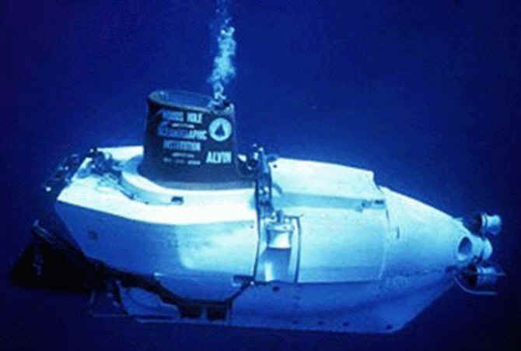
One year later we were ready to go explore the Titanic again. We went in a tiny, 3 man submarine called Alvin. It was hard to see in the dark ocean, but suddenly there was the enormous ship. The Titanic!

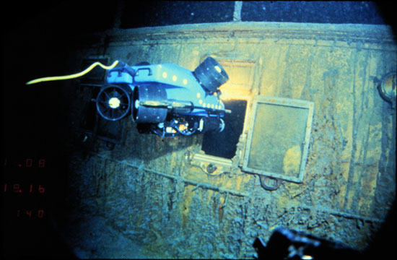

The next day we wanted to explore more so we landed Alvin near the opening to the Grand Staircase on the Titanic. It was a good place for our small robot named JJ to go inside.

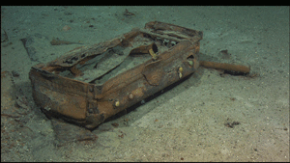

The little robot went inside and we watched the video as JJ’s driver explored the inside of the Titanic. We saw lots of things. There were even pots and pans, dishes, boots, and suitcases.

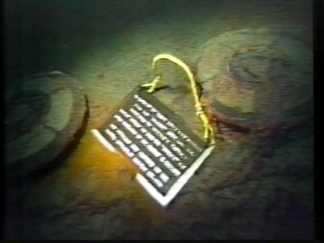

Before we left the Titanic we left two metal plaques. One was for the memory of the people who died on the ship, and the other was to tell others who find the Titanic to please leave it there.

Epilogue
I was sad when my trips to explore the Titanic were over. I am proud that we found the ship and have many beautiful pictures of it for people to see.
Ruth Becker was very lucky. She grew up to be a teacher. She didn’t like to talk about the Titanic.
After our trip more people went in the ocean to see the Titanic. They brought back many things from the wreck. I was very sad about this. I think the Titanic should be left in peace as a memory of all the people who died.


